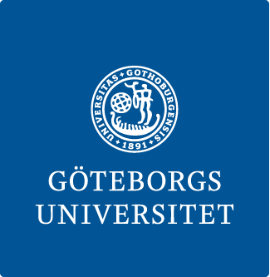

**Bachelor program KULTUR**

**Department of Cultural Sciences, University of Gothenburg**

**CERTIFICATION OF INTERNSHIP**

**Name of the workplace: _________________________________________________**

**Name of the trainee: ____________________________________________________**

**Time period for internship:** week 44 – 51 2025

At the beginning of the internship, an internship plan was drawn up between the internship host and the trainee, outlining the content, scope and design of the internship. It is hereby confirmed that the internship was carried out during the specified time period in accordance with the internship plan with regard to its content, scope and design.

**Place and date: _________________________________________**

_____________________________________________________

**Signature of the internship host**

_____________________________________________________

**Clarification of signature**

**The student leaves this certificate to the course leader at the final examination seminar in the end of the course at the University of Gothenburg.**